**Problem Statement-**

Autonomous bed cum wheelchair for elderly people to navigate within the house

**Concept-**

The low budget autonomous wheelchair uses a Robotic Operating System (ROS) for autonomous navigation. It creates a map of the surrounding space, along with static and dynamic obstacles, using a laser sensor and displays it through a smart phone app. The user can then touch any point on the generated map, and the wheelchair will drive to that place automatically without user intervention.

These automated wheelchair maps the surrounding environment, including dynamic and static obstacles such as people, walls, pillars, tables, chairs, etc. using a laser sensor called LiDAR. The map is automatically loaded onto an Android smart phone or tablet through a specially developed app.

**Challenges-**

The development of an algorithm for the self-driving wheelchair to perfectly map the environment and plan the proper path to the destination is the first challenge. Robotic Operating System (ROS) is used to address this successfully. The second challenge is avoiding dynamic obstacles like people and pets while the Self-E was navigating to the destination. The LiDAR sensor along with the Robotic Operating System helped by detecting such obstacles and recalculating a new path to the destination. Developing a cost efficient self-driving wheelchair was another issue. We used a single LiDAR sensor to keep the overall costs of the product as low as possible. Making the Self-E enter and exit through a door was a difficult task but we could succeed in this after fine-tuning the system.”

**ROS navigation-**

The Navigation Stack is fairly simple on a conceptual level. It takes in information from odometry and sensor streams and outputs velocity commands to send to a mobile base. Use of the Navigation Stack on an arbitrary robot, however, is a bit more complicated. As a pre-requisite for navigation stack use, the robot must be running ROS, have a [tf](http://wiki.ros.org/tf) transform tree in place, and publish sensor data using the correct ROS [Message types](http://wiki.ros.org/msg). Also, the Navigation Stack needs to be configured for the shape and dynamics of a robot to perform at a high level. To help with this process, this manual is meant to serve as a guide to typical Navigation Stack set-up and configuration.

**Sensors-**

### LiDAR-

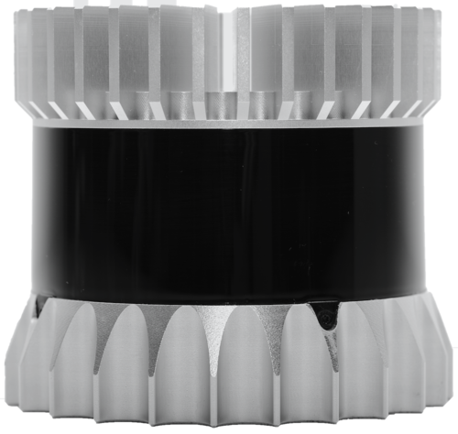

The primary "vision" unit on the autonomous vehicle is a LIDAR system, short for Light Detection and Ranging. The LIDAR system provides accurate 3D information on the surrounding environment. Using this data, the processor implements object identification, motion vector determination, collision prediction, and avoidance strategies. The LIDAR unit is well-suited to "big picture" imaging, and provides the needed 360⁰ view by using a rotating, scanning mirror assembly on the top of the car.

For close-in control, such as when parking, lane-changing, or in bumper-to-bumper traffic, the LIDAR system is not as effective. Therefore, it is supplemented by radars built into the front and rear bumpers and sides of the vehicle.

This is highly valuable information as it allows the vehicle to sense everything in its environment, be it vehicles, buildings, pedestrians or animals. Hence why so many development vehicles feature a large 360-degree rotating LiDAR sensor on the roof, providing a complete view of their surroundings.

### Cameras-

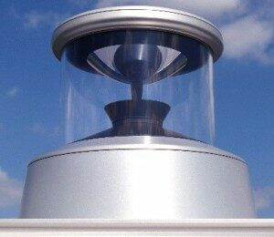

Autonomous vehicles are no different. Almost all development vehicles today feature some sort of visible light camera for detecting road markings – many feature multiple or panoramic cameras for building a 360-degree view of the vehicle’s environment. Cameras are very good at detecting and recognizing objects, so the image data they produce can be fed to AI-based algorithms for object classification.

The RGB data is converted to multiple gray scale images for different feature extractions. The gray scale data is filtered for noise and enhanced to improve feature contrast. Edge detection is used to enhance feature extraction. Isolated terrain obstacles are converted to binary representations. The terrain data is converted to a nearest obstacle edge histogram and combined with LRF data for obstacle avoidance and path planning. Multiple, color coated, binary images are combined for the terrain map visual interface.

### Radar-

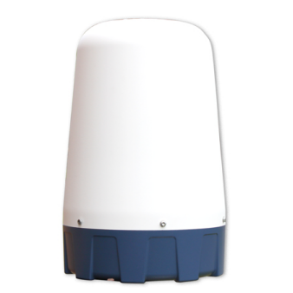

Radar works best at detecting objects made of metal. It has a limited ability to classify objects, but it can accurately tell you the distance to a detected object. However, unexpected metal objects at the side of the road, such as a dented guard rail, can provide unexpected returns for development engineers to deal with. Operating frequency for this radar is usually 77GHz, which has been allocated for this use, has good RF propagation characteristics, and provides sufficient resolution.

Much of the system-level operation involves measuring and managing the power requirements to control power, overall consumption, and thermal dissipation.

### Ultrasonic sensors-

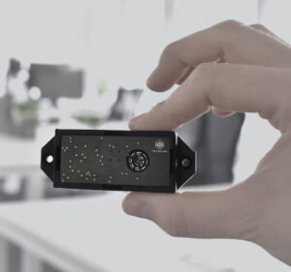

Ultrasonic sensors have been commonplace in cars since the 1990s for use as parking sensors, and are very inexpensive. Their range can be limited to just a few metres in most applications, but they are ideal for providing additional sensing capabilities to support low-speed use cases.

## **Putting It All Together-**

Camera, radar and lidar sensors provide rich data about the car’s environment. However, much like the human brain processes visual data taken in by the eyes, an autonomous vehicle must be able to make sense of this constant flow of information.

Self-driving vehicles do this using a process called sensor fusion. The sensor inputs are fed into a high-performance, centralized AI computer, such as the [NVIDIA DRIVE AGX](https://www.nvidia.com/en-us/self-driving-cars/drive-platform/hardware/) platform, which combines the relevant portions of data for the car to make driving decisions.

So rather than rely just on one type of sensor data at specific moments, sensor fusion makes it possible to fuse various information from the sensor suite — such as shape, speed and distance — to ensure reliability.

It also provides redundancy. When deciding to change lanes, receiving data from both camera and radar sensors before moving into the next lane greatly improves the safety of the maneuver, just as current blind-spot warnings serve as a backup for human drivers.

The DRIVE AGX platform performs this process as the car drives, so it always has a complete, up-to-date picture of the surrounding environment. This means that unlike human drivers, autonomous vehicles don’t have blindspots and are always vigilant of the moving and changing world around them.

**Conclusion-**

For the autonomous vehicle, the navigation and guidance subsystem must always be active and checking how the vehicle is doing versus the goal. For example, if the originally "optimum" route has any unexpected diversions, the path must be re-computed in real time to avoid going in a wrong direction.

We do know that such a vehicle demands a complex integration of sophisticated algorithms running on powerful processors, making critical decisions based on large streams of real-time data coming from a diverse and complex array of sensors.

**Already presented concepts in market-**

1. **Indian College research-**

Three final-year B.Tech students of Amrita Vishwa Vidyapeetham led by their professor have developed a self-driving wheelchair that can safely take a user from one point to another by navigating its own path and avoiding obstacles on the way. Called Self-E. It costs under 1lakh.

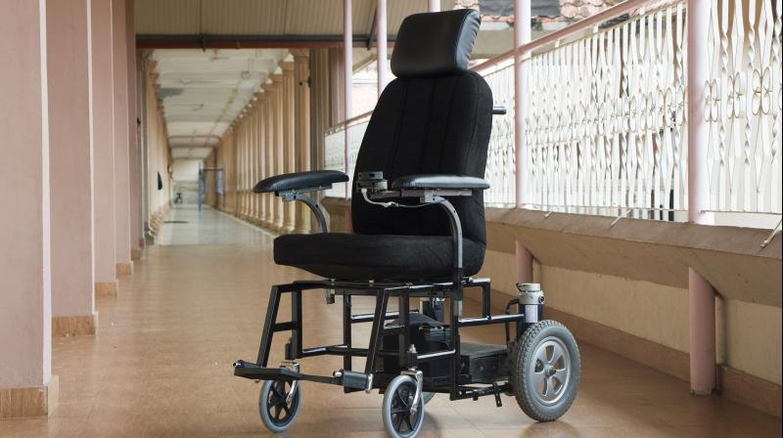

# **Human-Machine Interface for a Smart Wheelchair by** College of Engineering and Computer Science, California-

Their paper describes the integration of hardware and software with sensor technology and computer processing to develop the next generation intelligent wheelchair. The focus is a computer cluster design to test high performance computing for smart wheelchair operation and human interaction. The on board computer system is evaluated for cluster processing performance for the smart wheelchair, incorporating camera machine vision and LiDAR perception for terrain obstacle detection, operating in urban scenarios.

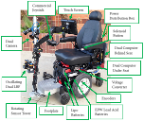

## A Japanese startup, Whill Hi-Tech Wheelchair-

WHILL Personal Electric Vehicles are bringing a fresh perspective to personal mobility with an innovative design and state-of-the-art technology—creating the confidence to drive anywhere with unprecedented independence and style.

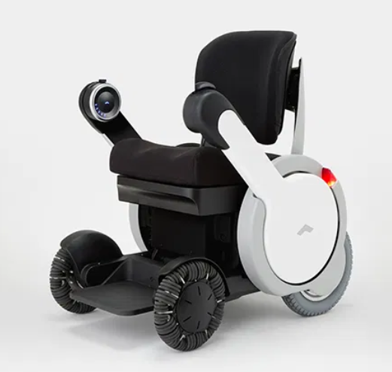

1. **Autonomous wheelchair developed by researchers at MIT and in Singapore promises improved independence for the disabled-**

The project's goal is to enhance an ordinary ordinary powered wheelchair using sensors to perceive the wheelchair's surroundings, a speech interface to interpret commands, a wireless device for room-level location determination, and motor-control software to effect the wheelchair's motion. The robotic wheelchair learns the layout of its environment (hospital, rehabilitation center, home, etc.) through a narrated, guided tour given by the user or the user's caregivers. Subsequently, the wheelchair can move to any previously-named location under voice command.

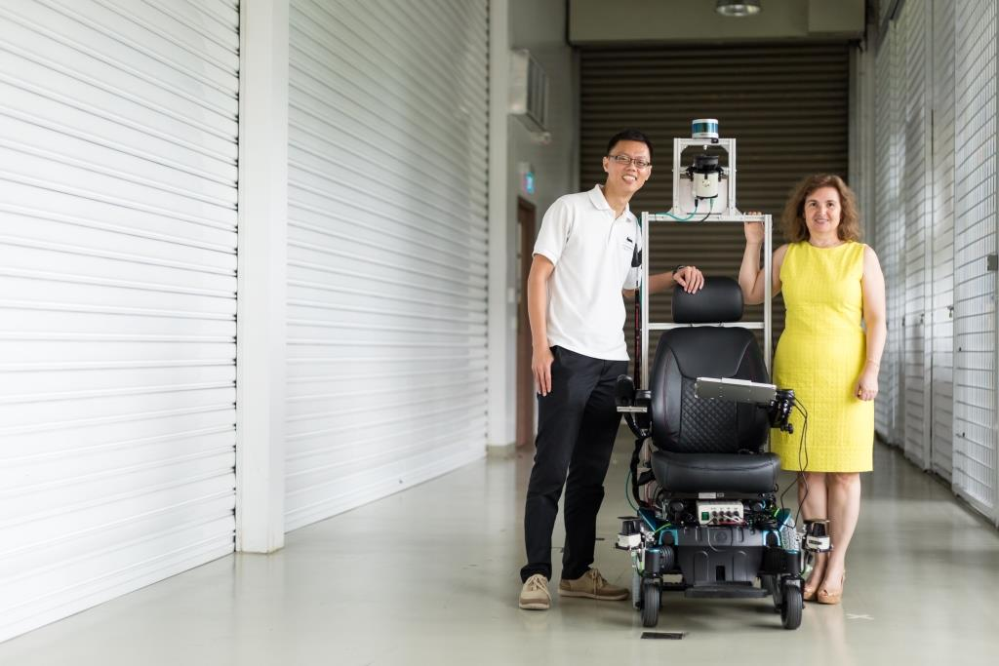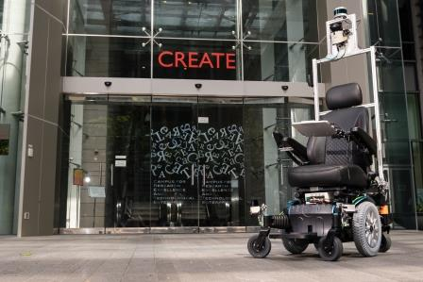

Advances are made on the technology of smart wheelchairs with sensors and driven by intelligent control algorithms to minimize the level of human intervention. The logical choice for introducing wheelchair automation into the mainstream market is to partner with manufacturers of assistive machines and serve as an additional offering. A boost in the autonomous driving industry could potentially serve as a watershed moment for this sort of advanced technology. People's comfort level and familiarity with autonomy is already increasing with current vehicles offering lane assist and emergency braking.